THANK YOU TO OUR SPONSORS
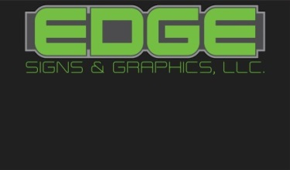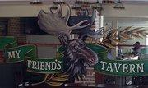
RICK OPPERMAN COLLEGEVILLE
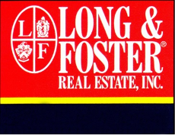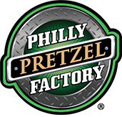
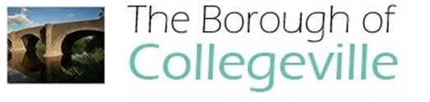

WELCOME TO THE 18TH COLLEGEVILLE FIRE COMPANY No.1
MAIN STREET CAR SHOW
MAP AND LEGEND ON THE INSIDE PAGES
SPONSORS ON THE BACK PAGE
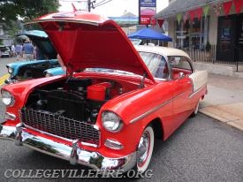
BRAD MILLS BAND @ FIRE STATION
12 NOON TO 3 PM
50/50 RAFFLE
HOPE YOU ENJOYED THE SHOW & HOPE TO SEE YOU NEXT YEAR.
COMMENTS CAN BE SENT TO:
34CARSHOW@COLLEGEVILLEFIRE.ORG
FOLLOW US @ WWW.COLLEGEVILLEFIRE.ORG
OR ON FACEBOOK @
HTTPS:// WWW.FACEBOOK.COM/COLLEGEVILLEFIRE
Twitter.com/collegeville34

